Training imaginative mind by planting seeds at Presbyterian School of Kabuga by Rev.Dr NDAYIZEYE MUNYANSANGA Olivier lecturer at PIASS

The Presbyterian School of Kabuga in Rwanda discovered that innovative activity of gardening helps students to carry out different practices responsibly at school and at home. It is a crucial part of teaching because it leads to creativity and innovation. It is a valuable life skill tool which can influence the all life.
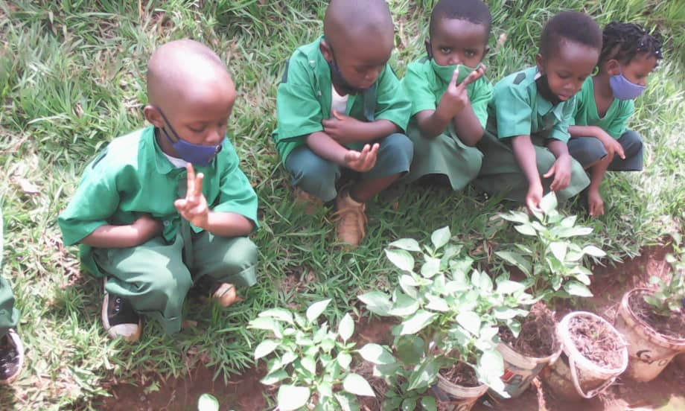
By inviting small kids to plant seeds, this action wakes up generally their spirit of innovation and inventiveness that leads to the improvement of their learning process and develop their individual’s capabilities. The action of planting is considered also as a positive contribution to the society. It increases their confidence and their spirit of taking care and following up. It was discovered that gardening is a perfect metaphor for innovation development and generates new knowledge.
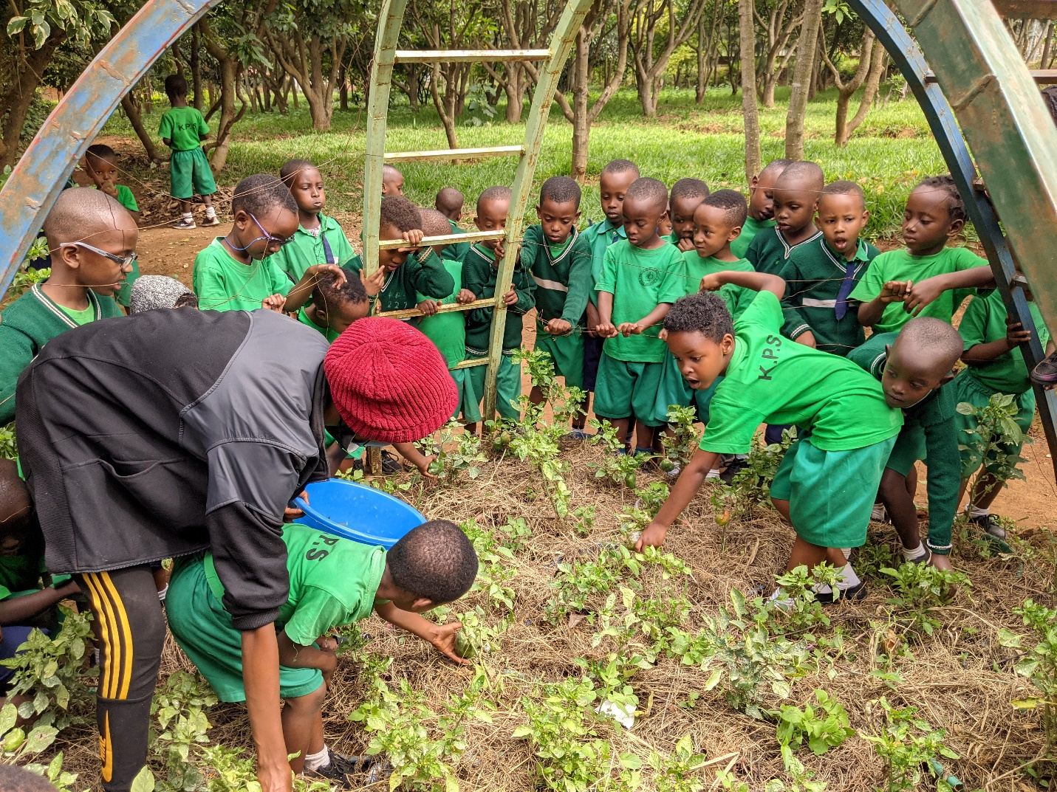
Before the harvest, student are involved in a systematic work effort of watering, taking care, removing bad herbs, protecting the vulnerable plant against sun and heavy rains, harmful insects. This practice develop their creative and innovative capacities. In the Presbyterian School of Kabuga, planting seeds is included in the curriculum and is became an integral piece for all students to succeed.
After harvesting their own fruits, they cook and share joyfully the meal as a result of their own handwork. The most influential kid’s abilities is the capacity to create. If you create something every single day then your spirit of creativity grows. It influence the greater long-term success in a variety of areas.

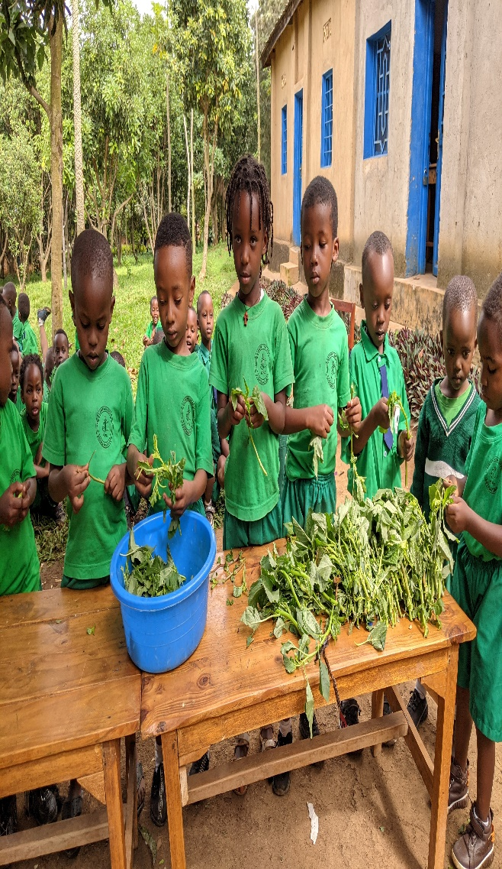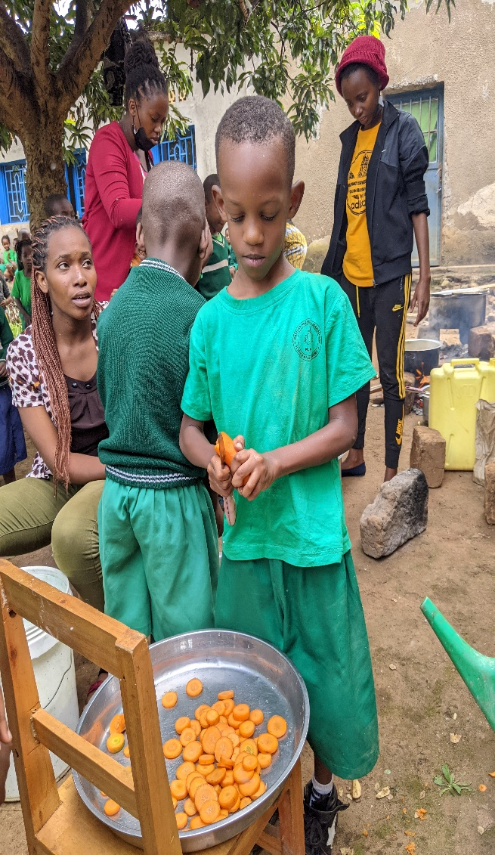
The school trains students practically for using theirs hands. Innovation is putting the idea into practice. For Christianity, it is where also God intervenes for blessing the human action. Success in development is the accumulation of small actions and knowledge. With the simple action of planting seeds, a student can change, can influence, and can create, and he or she will never be the same again.

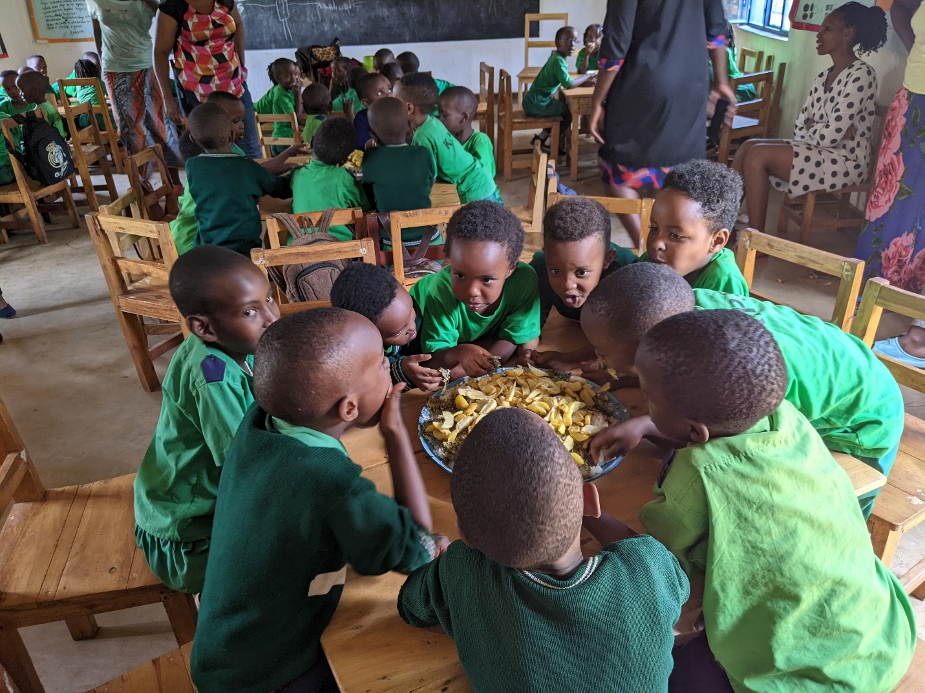
Gardening maintains good communication, timework, friendship, and the interest to connect with the nature. In addition, it provides nutritious veggies foods which offers a variety of health benefits.

