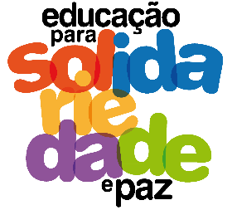
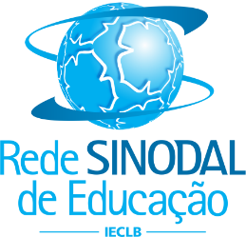
26th YOUNG LEADERSHIP MEETING
May 30 to June 1
Gustavo Adolfo Synodal College – Lajeado/RS

TOPIC: Education for Solidarity and Peace

30.05 – quinta-feira

1:30 p.m. – Greeting and meditation
2:00 p.m. – Cooperative Games
4:00 p.m. – Break
4:30 p.m. – General Lecture: Circles of Peace
5:30 p.m. – General information and visit to the school
5:45 p.m. – Going to the hosts

05.31 – Friday
8:00 a.m. – Meditation
8:20 a.m. – Leadership that make/has made a difference in society
10:00 a.m. – Break
10:30 a.m. – Continuity of work
12:15 a.m. – Lunch
1:30 p.m. – Workshops for Solidarity and Peace
- FLD (Not So Sweet Home/Gender Justice)
- FLD (Fair and Solidarity Trade)
- CAPA (Good Meal at the Table)
- COMIN (Intercultural and Interreligious Dialogue)
- SERPAZ (Nonviolent Communication)
- Overcoming Trauma (Diakonia - IECLB)
6:30 p.m. – Going to the hosts
8:00 p.m. – Dinner and Integration

06.01 – Saturday
8:00 a.m. – Peace and discord in Protestant schools around the world (Creating the Garden of Peace), based on the GPEN proposal.
10:00 a.m. – Break
10:30 a.m. – Evaluation and final celebration
12:00 a.m. – Conclusion lunch

