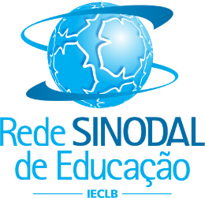
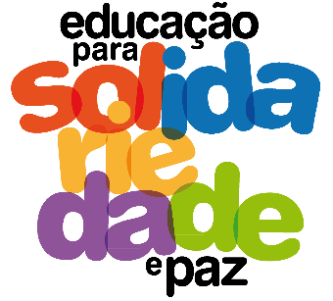
NATIONAL MEETING OF RELIGIOUS TEACHING TEACHERS
May 30 to June 1
Gustavo Adolfo Synodal College – Lajeado/RS

TOPIC: Education for Solidarity and Peace

05.30 – Thursday - Arrive until 1:00 p.m.

1:30 p.m. – Greeting and meditation
2:00 p.m. – Cooperative Games
4:00 p.m. – Break
4:30 p.m. – General Lecture: Circles of Peace
5:30 p.m. – General information and visit to the school
6:30 p.m. – Going to the hosts

05.31 – Friday
8:00 a.m. – Meditation
8:20 a.m. – TED TALKS – Ideas and practices that deserve dissemination
- FLD (Not So Sweet Home/Gender Justice)
- FLD (Fair and Solidarity Trade)
- CAPA (Good Meal at the Table)
- COMIN (Intercultural and Interreligious Dialogue)
- SERPAZ (Nonviolent Communication)
- Diakonia Network (Strengthening Diakonal Institutions)
- Overcoming Trauma (Diakonia - IECLB)
10:00 a.m. – Break
10:20 a.m. – Training workshops for Solidarity and Peace
- FLD (Not So Sweet Home/Gender Justice)
- FLD (Fair and Solidarity Trade)
- CAPA (Good Meal at the Table)
- COMIN (Intercultural and Interreligious Dialogue)
- SERPAZ (Nonviolent Communication)
- Overcoming Trauma (Diakonia - IECLB)
12:15 a.m. – Lunch
1:30 p.m. – Testimonials from schools that carry out social and/or community projects
3:30 p.m. – Curriculum of Religious Teaching and Education for Solidarity and Peace
6:30 p.m. – Going to the hosts
8:00 p.m. – Dinner and Integration

06.01 – Saturday
8:00 a.m. – Two groups:
- Ministers of School Pastoral - The identity of School Pastoral in the School and the "Partnership" with the IECLB

- Religious Teaching Teachers – The place and importance of religious experiences and practices in school

10:00 a.m. – Break
10:30 a.m. – Evaluation and final celebration
12:00 a.m. – Conclusion lunch

